1. Kth smallest

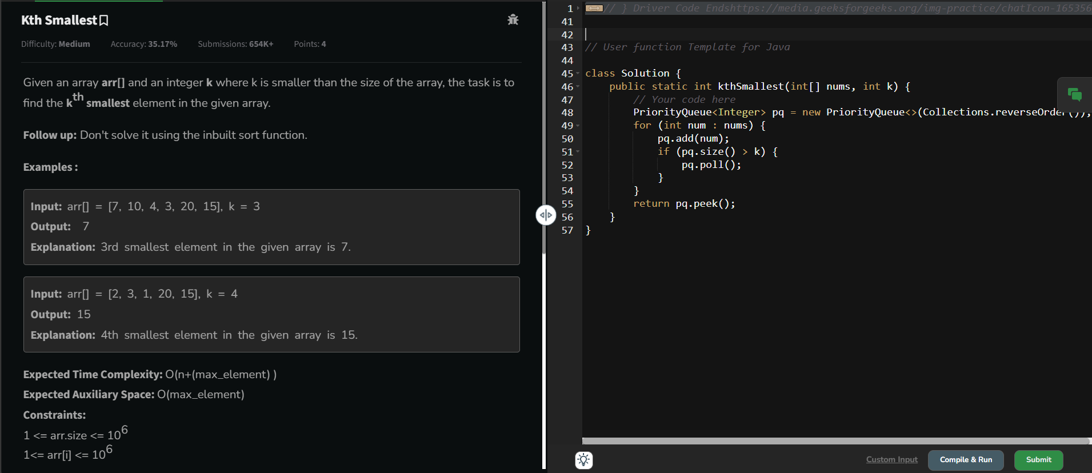

Time complexity: O(n)

2. Minimum Height II

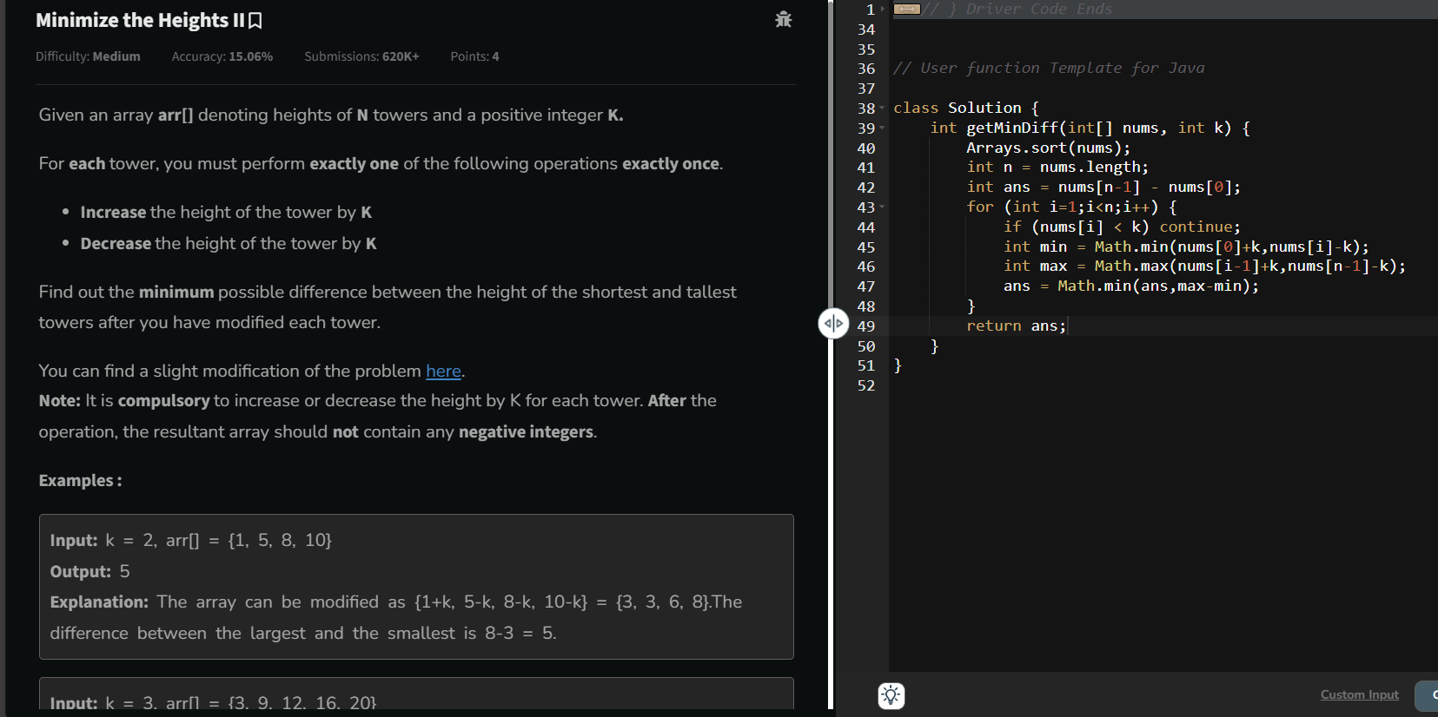

Time complexity: O(n)

3. Parenthesis checker

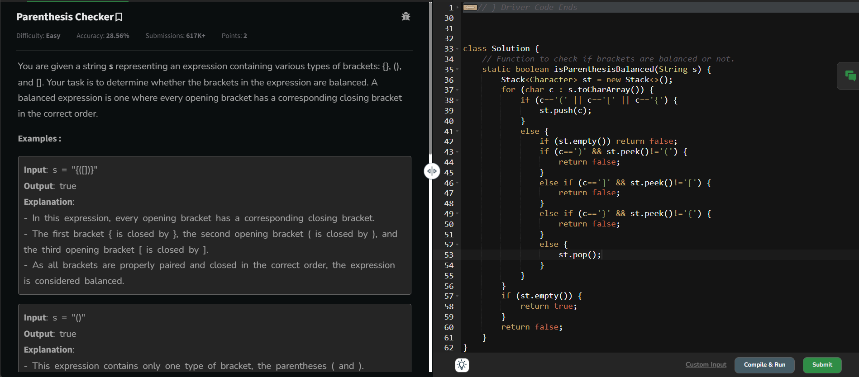

Time complexity: O(n)

4. Equilibrium point

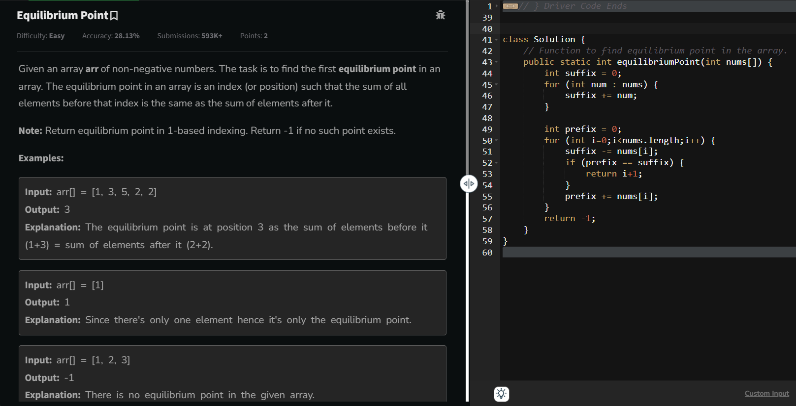

Time complexity: O(n)

5. Binary search

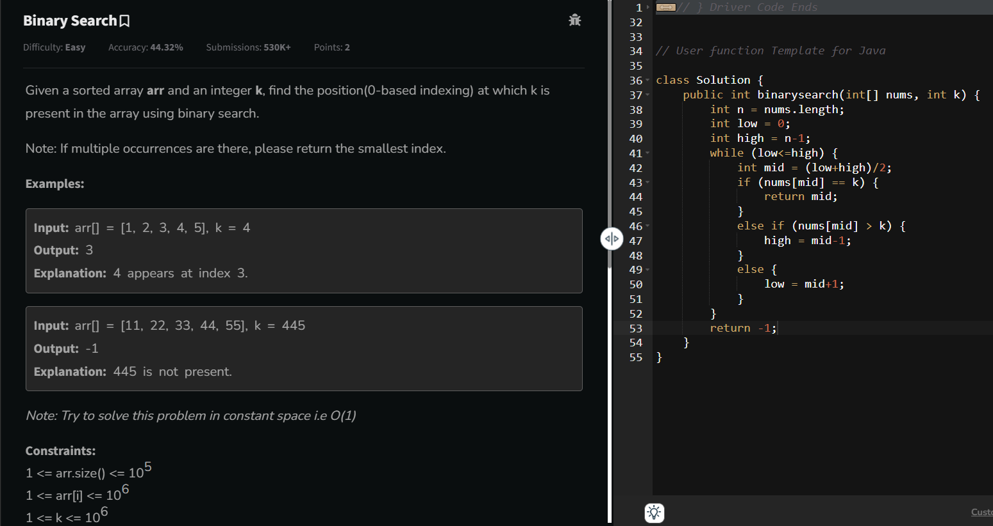

Time complexity: O(log n)

6.

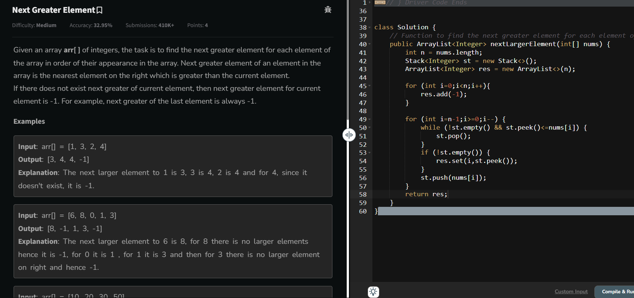

Time Complexity: O(n)

7.

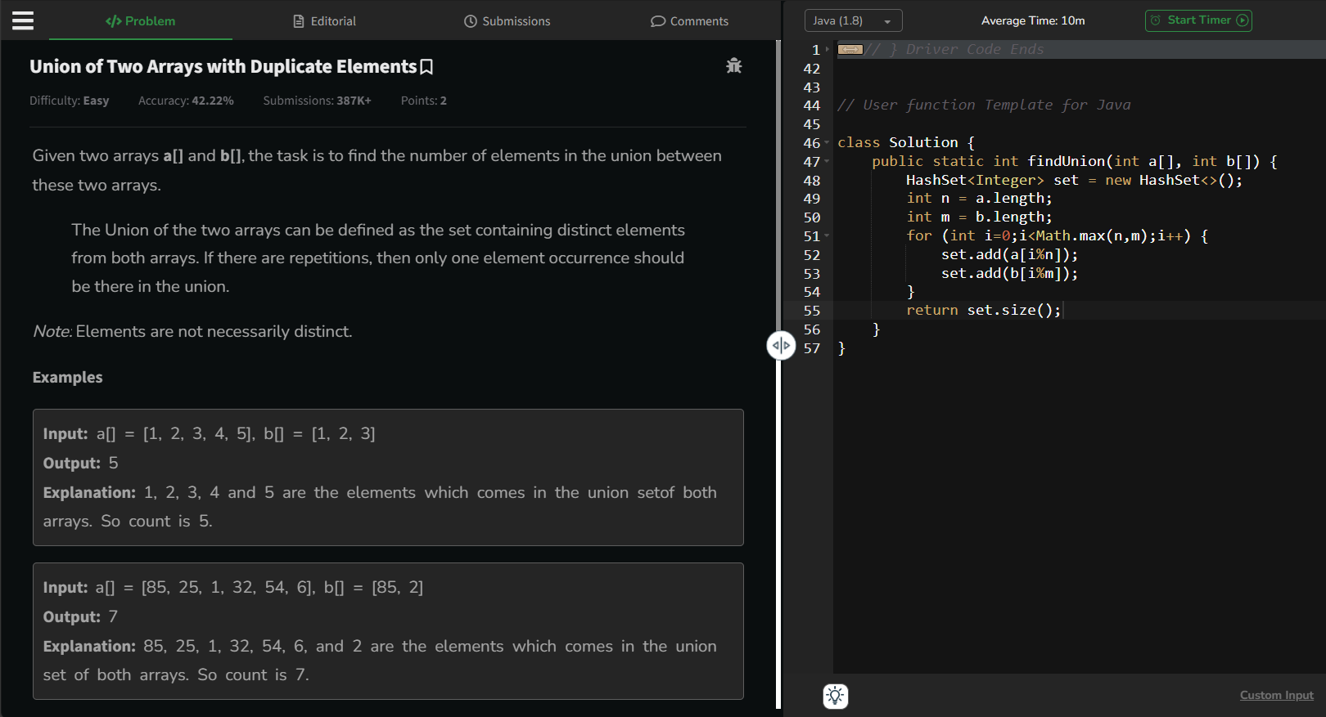

Time Complexity: O(n)